Case 6-Afr-DR Congo*-N’kisi nkondi*-Statue-Male-Wood-19th c

Note: The Democratic Republic of the Congo (DR Congo) has been known as, in chronological order, the Congo Free State, Belgian Congo, the Republic of Congo-Léopoldville, the Democratic Republic of the Congo and the Republic of Zaire, before returning to its current name the DR Congo.

Note: The Kongo people (singular: Mukongo, pl. Bakongo) speak Kikongo, a Bantu language, who have lived along the Atlantic coast of Central Africa, in a region that, by the 15th century, was a centralized and well-organized Kongo Kingdom but is now a part of three countries: DR Congo, the Republic of the Congo and Angola.

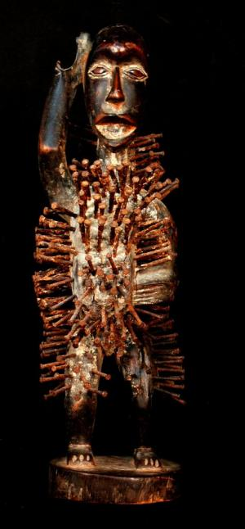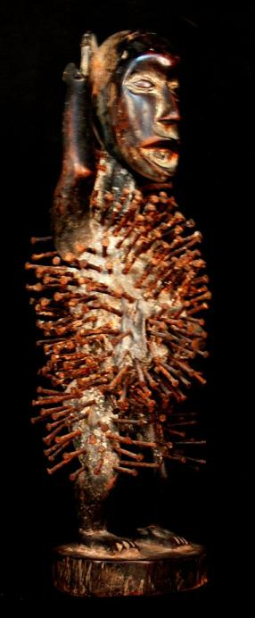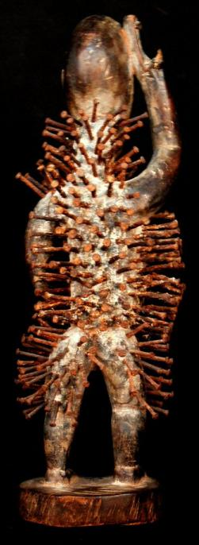

Fig. 13 a-c. A000-Afr-Congo DR- *N’kisi nkondi*-Statue-Male-Wood-19th c Atlantika Collection.

**Case no.: 6**

**Accession Number:**

**Formal Label:** Congo DR- *N’kisi nkondi*-Statue-Male-Wood-19th c

**Display Description:**

This figure is a *nkisi* (plural *minkisi*) of the type known as *nkondi* (plural *minkondi)* from the Congo basin in west central Africa. *Nkisi* is a general term referring to spirits and the objects that house them. *Nkondi* refers more specifically to the category of objects were carved and animated by hammering nails into its body by *nganga* (ritual specialists), who would work in conjunction with a supplicant or a separate artisan. The carved figure (usually anthropomorphic, but occasionally taking the form of an animal such as a dog or panther) would act as a container, which would be animated and empowered by the insertion of a parcel of medicine (*bilongo*).



Three *nkisi,* Boma, Congo, 1902.

In the case of the this *nkisi*, this *bilongo* would have been sealed into the cavity on the figure’s abdomen. Once animated by the *nganga*, supplicants would drive nails and other objects into the *nkisi* in order to enrage the spirit into action for the purposes of vengeance, protection, healing, or dispute resolution. It has been reported that two *nkisi nkonde* could be hit together to achieve the same kind of spiritual animation. In other instances, *minkondi* could be used to sanction an oath; if the oath were broken, the spirit would be released to pursue the party that breached the agreement and to effect a psycho-social restitution. Reflecting this function, *nkisi nkondi* are often depicted in the pose of hunters, and the word *nkondi* is derived from the word *konda* meaning “to hunt.” *Nkisi* were never intended for aesthetic contemplation as they had an important psycho-social function and were meant to be used to resolve a specific communal purpose.

**LC Classification: NB1099 C6**

**Date or Time Horizon:** 19th c

**Geographical Area:** Congo DR

**Map:**

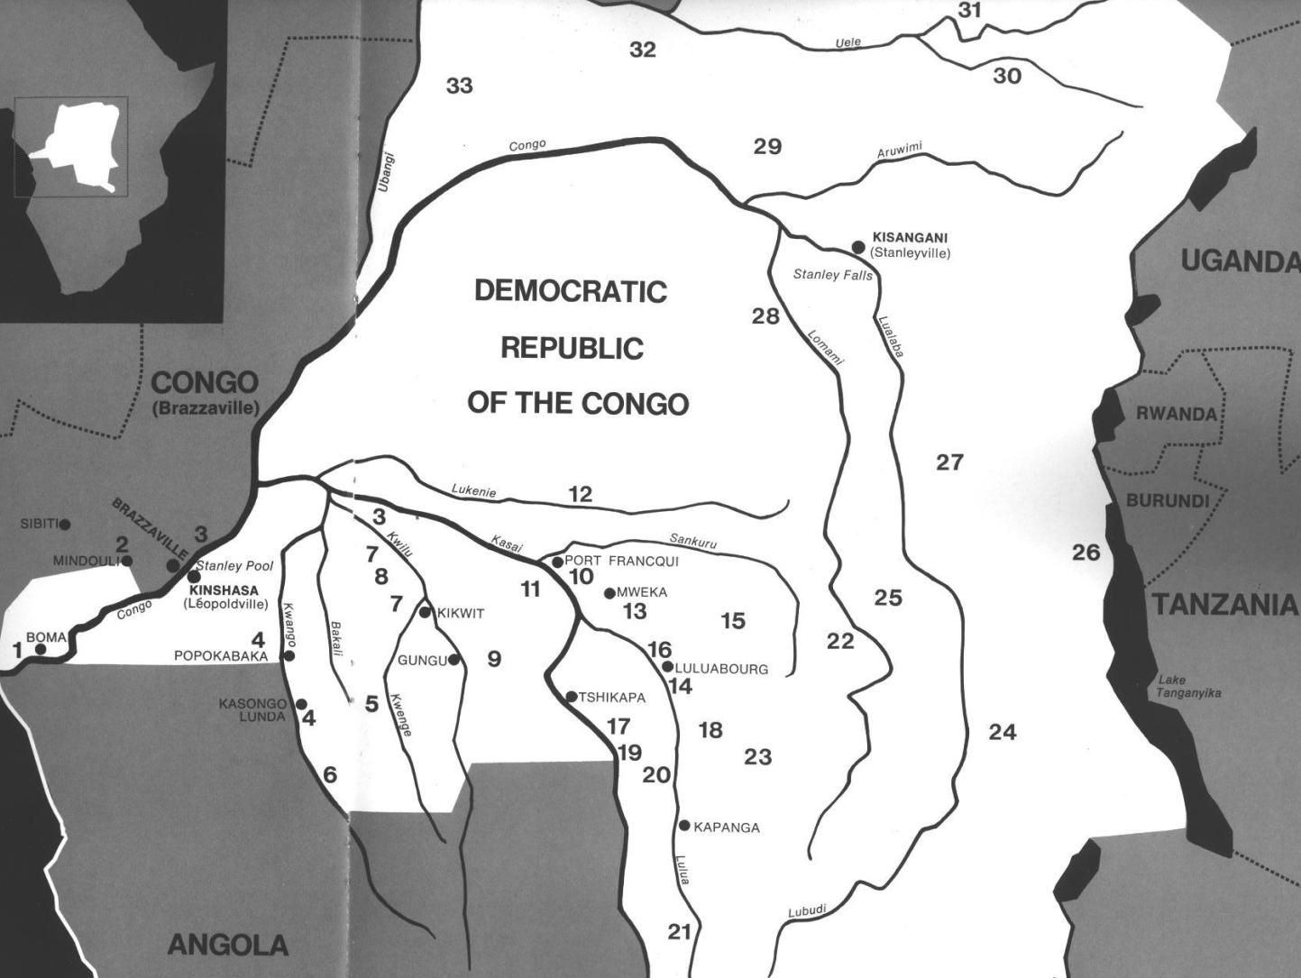

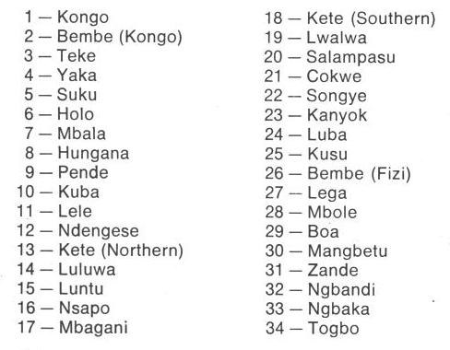

Fig. 1. Map of Kongo Cultures, West Central Africa. After Walker Art Center 1967.

**GPS coordinates:**

**Cultural Affiliation:** Kongo

**Media:** wood, iron nails

**Dimensions:** H 12.20 in

**Weight: 1.19 pounds**

**Condition: original**

**Provenance:** Kinshasa

**Discussion:**

This *n’kisi nkondi* has embedded iron nails (*nkonso*) which were hammered into its surface marking the incidences of personal encounters with other humans or spirits and concluding with resolution (Laman 1953, vol. 3, p. 86). The totality of these nails presents a remarkable testimony to the efficacy of Kongo psycho-social therapy, since each nail represents such a transaction.

Kongo figural protocol is predicated on animating the object in order that it will be effectively animate. One of the basic demands is that the knees be bent to signify it is a sentient being, which has been engaged by the *bilongo* or activating energy. This *bilongo* may also be seen in its gestural language to engage the client. In this case the figure has its right hand raised above its ear as though requesting the client to speak louder, its mouth is open (*bamuna)* as if it has spoken or is speaking and its left arm is by its side. Its eyes challenge (*mambo*) the client beseeching him with the power of *Kalunga*, the spiritual agent, demanding one to divulge the truth. Nails embedded in the figure represent strongly felt desires, requests for protection, requests for defense and empowerment each is sealed with a solemn vow or “tied *mambo*” (Thompson 1978).

The so-called “art criticism” of *n’kisi nkondi* reflects a lack of anthropological context. Kongo communal societies have not engaged in aesthetically designed works and this is true for societies whether they be Western, African, Native American or Eastern. It is pointless to refute those who engage in solely artistic critiques of these objects, since the two planes of reality, art criticism and anthropology, rarely intersect. A good treatment of this debate from one who is familiar with both sides and articulates the issues succinctly, especially with regard to *n’kisi nkondi,* is Henry Skeritt at *https://henryfskerritt.com/2013/01/04/objects-of-power-and-the-power-of-objects/*, *https://virginia.academia.edu/HenrySkerritt.*

**References:**

Adams, Monni. 1988. 8th century Kuba king figures, *African Art* 21(3): 32-38, 88.

Belepe, Bope. 1974. *Etude socio-morphologique des masques Bwoom des Kuba: Memoire de licence en histoire.* Lubumbashi: Université Nationale du Zaire.

Belepe, Bope. 1981. Les oeuvres plastiques Africaines comme documents d'histoire: Le cas des statues Royales Ndop des Kuba du Zaire, *Africa­Tervuren* 25(1): 9-17.

Binkley, D. 1987. Avatar of power: Southern Kuba masquerade figures in funerary context, *Africa* 57 (1).

Binkley, D. 1990. Masks, space and gender in southern Kuba initiation ritual, *Iowa Studies in Art.* Vol. 3, *Art and Initiation in Zaire.* Iowa City: The University of Iowa.

Brett-Smith, Sarah. 1983. “The Doyle Collection of African Art,” *Record of the Art Museum, Princeton University*, 42(2): 2+8-34.

Kuba du Zaire, Africa­ Tervuren 27(1): 9-17.

Binkley, D. 1987. Avatar of power: Southern Kuba masquerade figures in funerary context, *Africa* 57 (1).

Binkley, D. 1990. Masks, space and gender in southern Kuba initiation ritual, *Iowa Studies in Art.* Vol. 3, *Art and Initiation in Zaire.* Iowa City: The University of Iowa.

Claerhout, A. 1976. Two Kuba wrought-iron statuettes, *African Art* IX (4): 60-64.

Cornet, J. 1972. *Art de l'Afrique Noire au pays du fleuve Zaire*. Brussels: Arcade.

Cornet, J. 1975. *Art from Zaire: 100 Masterworks from the National Collection.* New York: African-American Institute.

Cornet, J. 1982. *Art royal Kuba.* Milan: Sipiel.

Ehret, Christopher. 2002. *The civilizations of Africa: a history to 1800*. Charlottesville: Virginia: University of Virginia Press.

Forbath, Peter. 1977. *The River Congo*. Boston: Houghton Mifflin.

Laman, Karl. 1953. *The Kongo*. 4. vols. Stockholm: Victor Pettersons.

MacGaffey, Wyatt. 1986. *Religion and society in central Africa: the Bakongo of Lower Zaire*. Chicago: University of Chicago Press.

MacGaffey, Wyatt. 1988. “Complexity, astonishment and power: the visual vocabulary of Kongo minkisi,” *Journal of African Studies*, (14:2), 188-203.

Martinez-Ruiz, Barbaro. 2013. *Kongo Graphic Writing and other Narratives of the Sign*. Philadelphia: Temple University Press.

Rosenwald, J. B. 1974. “Kuba king figure,” *African Art,* VII (3).

Schadeberg, Thilo. 1999. “Batwa: the Bantu name for the invisible people.” In *Challenging Elusiveness: Central-African Hunter Gatherers in a Multidisciplinary perspective*, ed. K. Beibrouck, S. Elders, and G. Rossel. Leiden: CNWS, 21-39.

Skeritt, Henry. 2013. *https://virginia.academia.edu/HenrySkerritt*

Thompson, Robert Farris. 1978. “The Grand Detroit N’kondi,” *Bulletin of the Detroit Institute of Arts* 56 :4, 206-217.

Torday, E. and T. A. Joyce. 1911. « Notes ethno­graphiques sur les peuples communement appeles Bakuba, ainsi que sur les peuplades apparentees, les Bushoongo. » In *Annales du Musee Royal du Congo Belge, Ethnographie et Anthropologic.,* serie III, tome II, fasc. 1. Brussels: Tervuren.

Vansina, Jan. 1955 “Initiation Rituals of the Bushong,” *Africa* 25(2): 138-153.

Vansina, Jan. 1964. *Le royaume kuba.* Tervuren: Musée royal de l'Afrique centrale.

Vansina, Jan. 1978. *The children of Woot. A history of the Kuba peoples.* Madison: University of Wisconsin Press/Dawson.

Vansina, Jan. 1984. *Art History in Africa.* London: Longman.

Van Wing, Joseph Hubert Leopold. 1941. *Études Bakongo*. II. *Religion et magie*. Institut royal colonial belge. Section des sciences morales et politiques. Mémoires, collection in-8°, t. IX, fasc. 1. Brussels: Desclée de Brouwer.

Van Wing, Joseph Hubert Leopold. 1959. *Études Bakongo.* Brussels: Desclée de Brouwer.

Walker Art Center. 1967. *Art of the Congo*. Minneapolis: Walker Art Center.